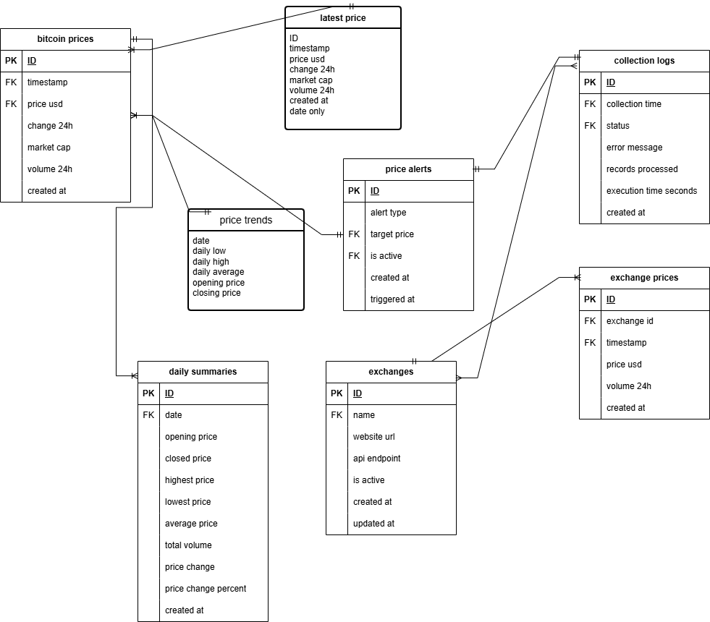

ERD for Bitcoin Price Tracker

Tables and Relationships

Main Tables:

1. bitcoin prices (Primary table)
Stores individual price records collected at regular intervals
Contains timestamp, price, 24h change, market cap, and volume data
Primary key: id
Indexes on timestamp and price for performance

2. daily summaries
Stores aggregated daily data (open, high, low, close, average)
Calculated from bitcoin prices table
Provides quick access to daily trends
Unique constraint on date

3. price alerts
Configurable price alerts for notifications
Can trigger when price goes above or below target
Tracks when alerts were triggered

4. collection logs
Logs of data collection attempts
Tracks success/failure rates and execution times
Used for monitoring system health

5. exchanges
Information about different cryptocurrency exchanges
For future expansion to multiple data sources
Stores API endpoints and website URLs

6. exchange prices
Historical prices from different exchanges
Foreign key relationship to exchanges table
Enables comparison of prices across exchanges

Relationships:

exchanges (1) → (many) exchange prices
bitcoin prices → daily summaries (calculated relationship)
All tables have created at timestamps for auditing

Normalization:

Database is in 3NF (Third Normal Form)
No transitive dependencies
All non-key attributes depend only on the primary key
Proper foreign key constraints maintain referential integrity

Views:

latest price: Shows the most recent price for each day
price trends: Provides daily OHLC (Open, High, Low, Close) data

Indexes:

Strategic indexes on frequently queried columns
Composite indexes for common query patterns
Improves performance for time-based queries

